I developed this bot to explore the new preview feature in co-pilot related to image analysis and how we can use it in a real case senarios. This agent can be used to check the sentiment of the customers or check items scanned by an X-ray machine. This agent can be integrated with X-ray machines, where the machine sends images to the agent for analysis. The agent then evaluates the contents of the items in the image and takes appropriate actions if restricted items are detected. Also it can be integrated wth cameras to check the sentiment of customers.

- Check Sentiment: it returns the sentiment of the customer based on his image captured.
- Weapon Detection: If a weapon is identified, the agent will automatically generate a case for law enforcement and notify security personnel.
- Electronic Device Detection: If an electronic device is found, the agent will alert security for further inspection, and the co-pilot can send an instruction to the machine to retain the bag.
- No Restricted Items: If no restricted items are detected, the agent will send a notification confirming the clearance.
This pilot agent can significantly reduce human error in surveillance, streamline the monitoring process, and enhance the overall security of the airport. Additionally, it logs all actions for future analysis, helping optimize operational efficiency and resource management.

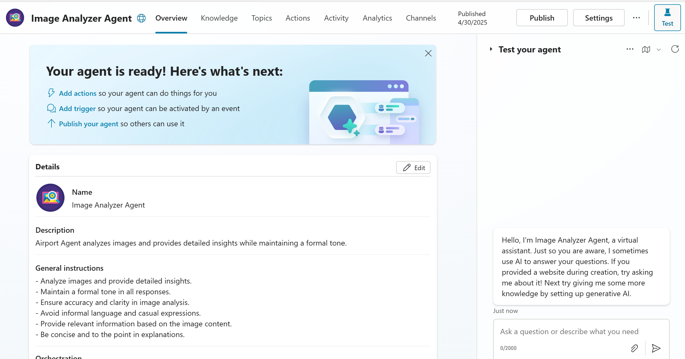

To test this agent you can upload the image manually, please check the below senarios:

- Check Sentiment: it returns the sentiment of the customer based on his image captured.
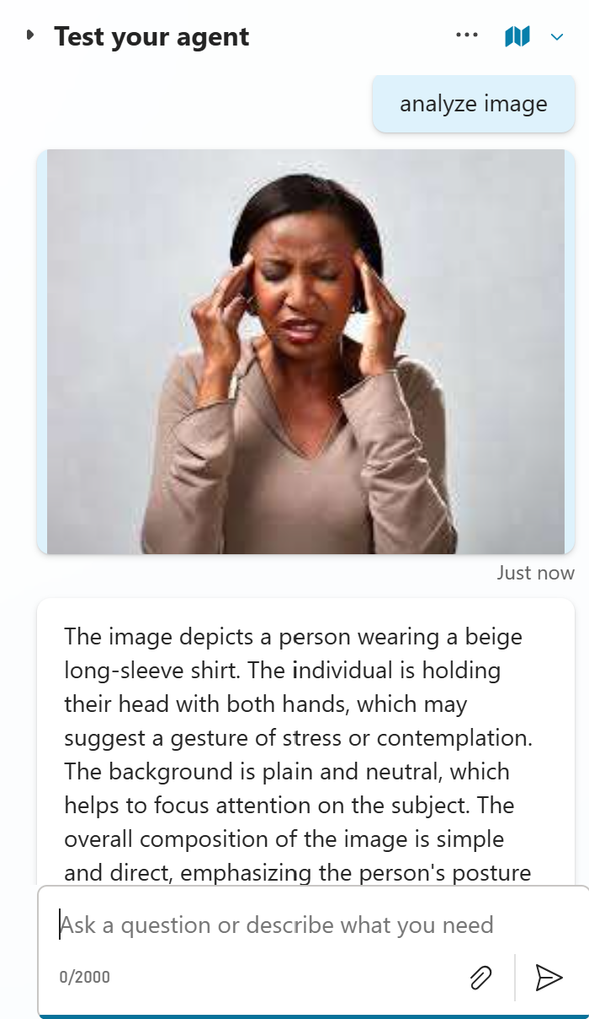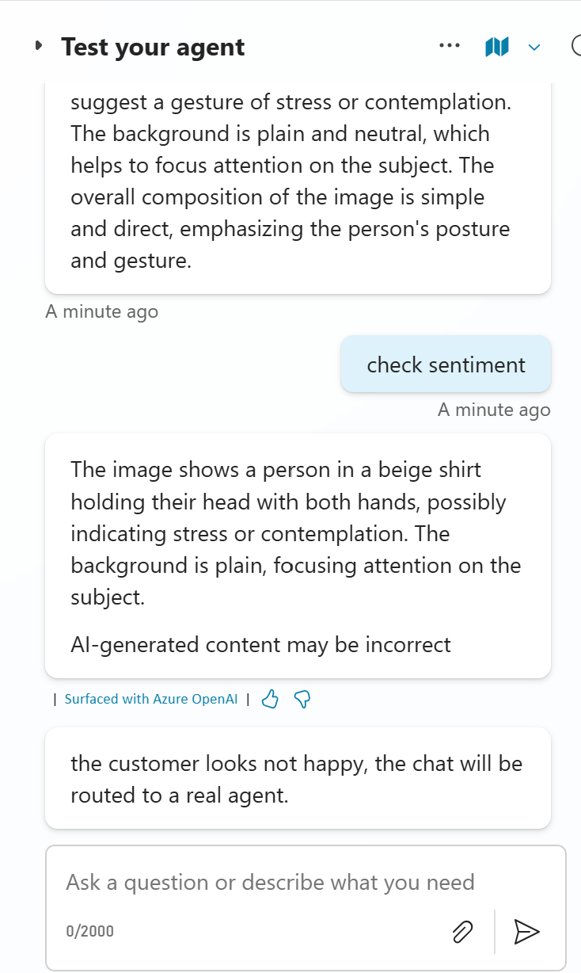

- Weapon Detection: If a weapon is identified, the agent will automatically generate a case for law enforcement and notify security personnel.
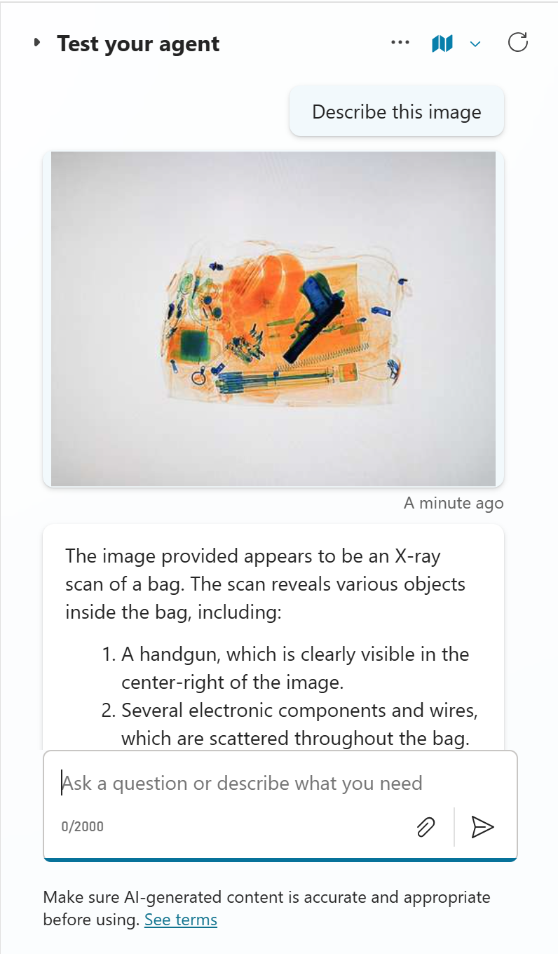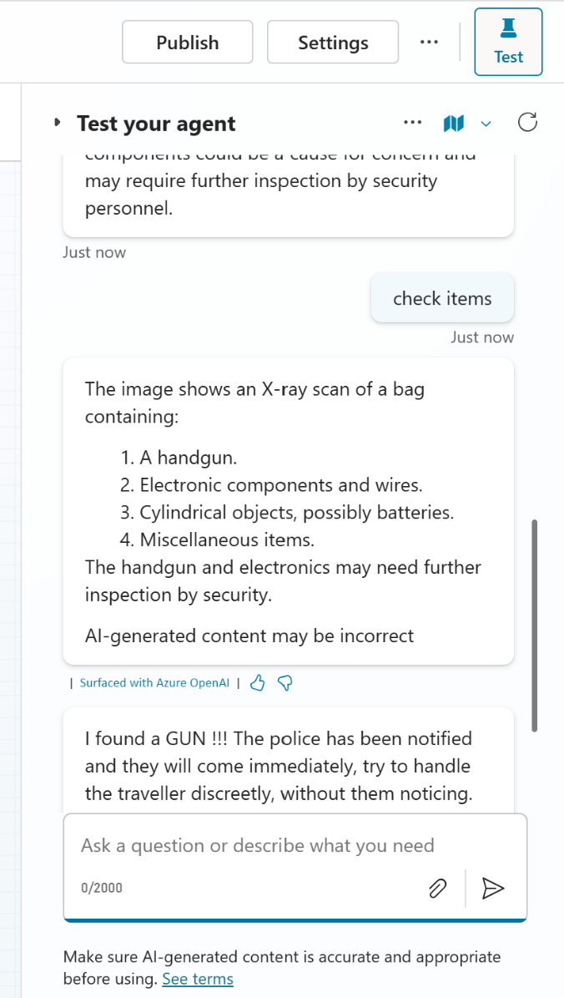

- Electronic Device Detection: If an electronic device is found, the agent will alert security for further inspection, and the co-pilot can send an instruction to the machine to retain the bag.
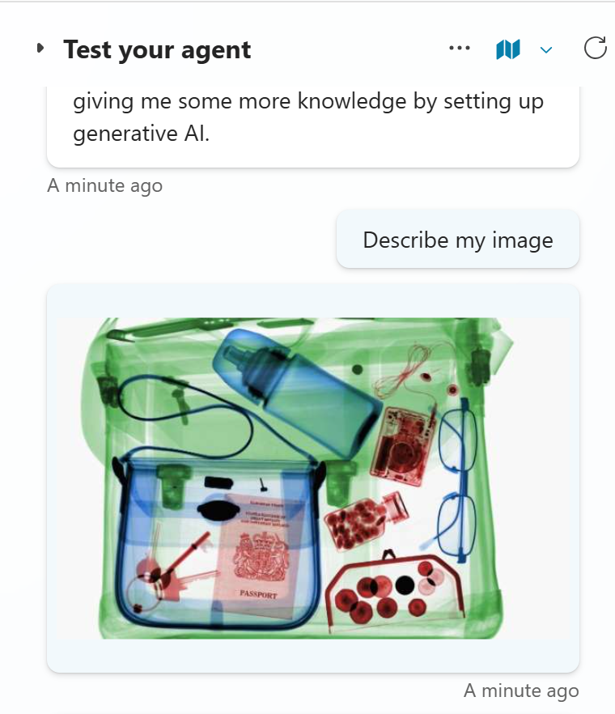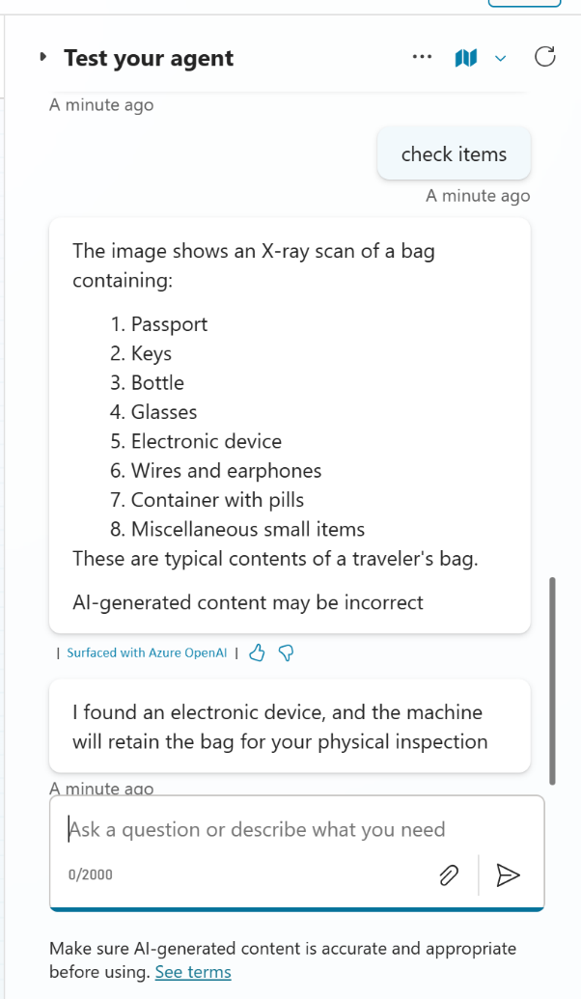

- No Restricted Items: If no restricted items are detected, the agent will send a notification confirming the clearance.

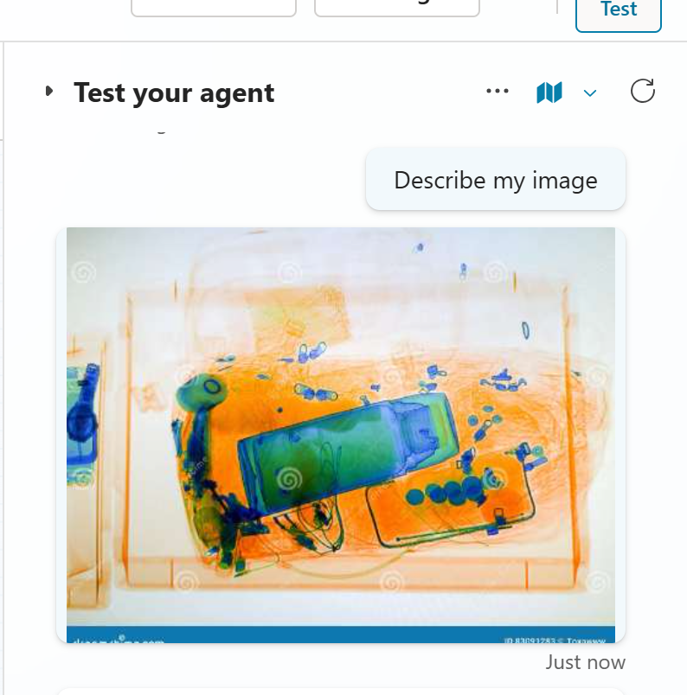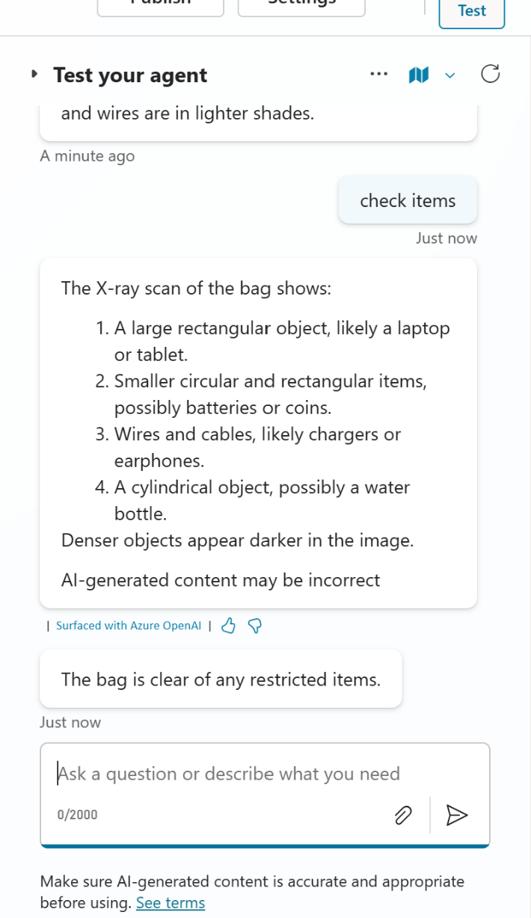

Topics developed :

